Design patterns :factory & singleton
Hiba mhirit
Exercice1 :
Database class :
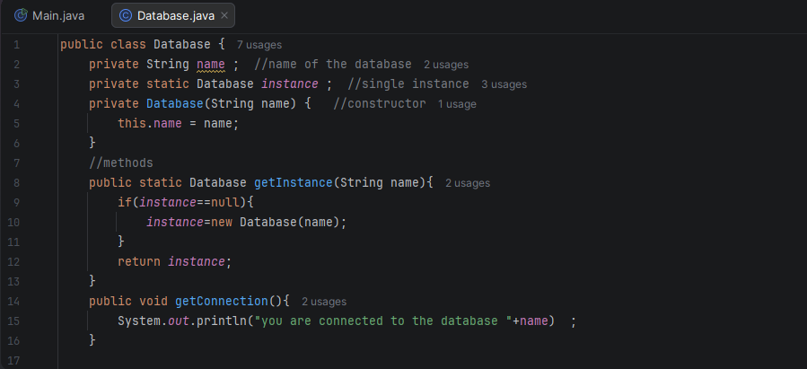

Main :
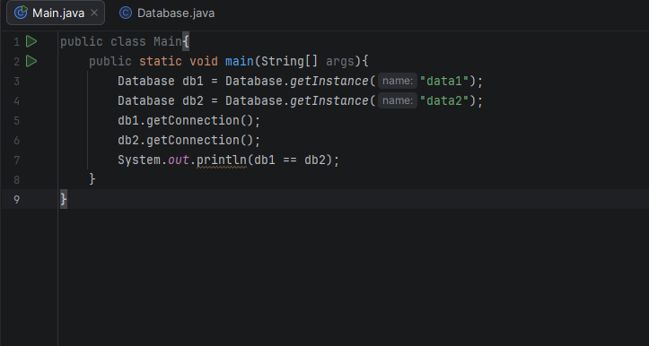
Output :
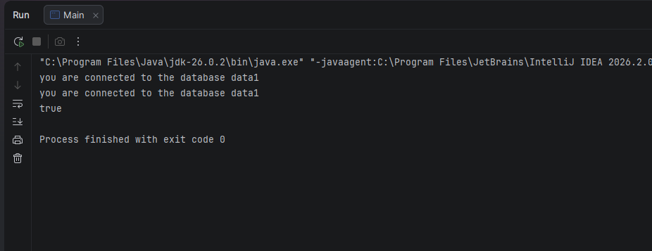
Exercice2 :
1-naive solution :
Code :
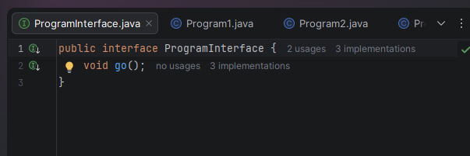
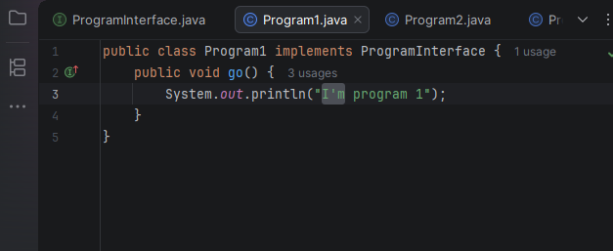
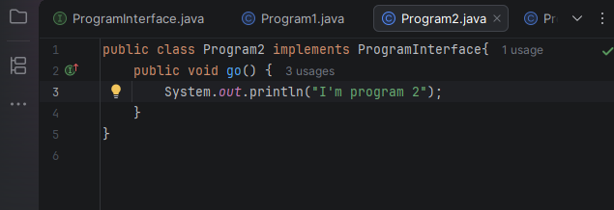
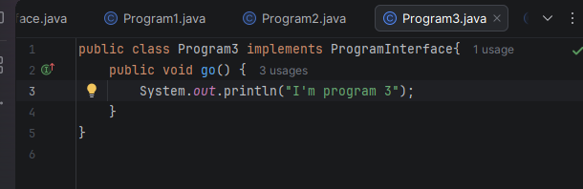
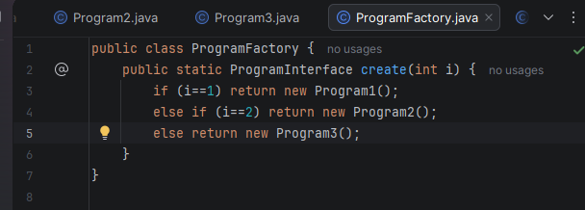
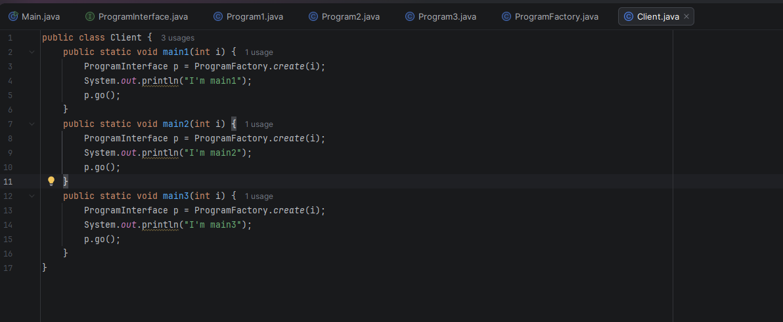
Output :
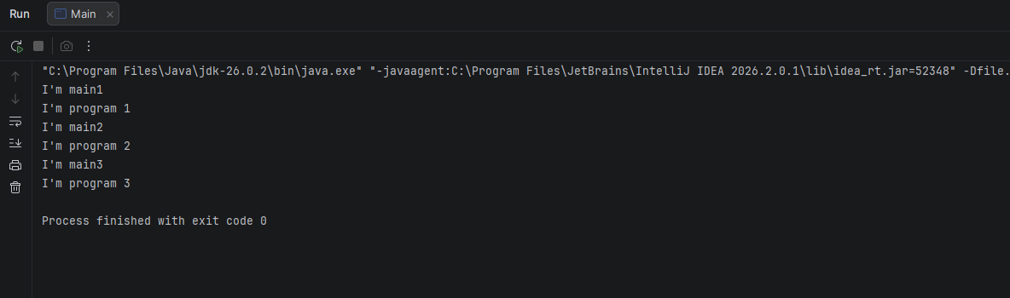
3-what do we notice +problems
We notice that the code that creates the Program objects (the if/else block) is duplicated in main1, main2 and main3, which is bad practice. This makes the code hard to maintain: to add a new class such as Program4, we would have to modify all three methods, and we could easily forget one of them. It also creates tight coupling, because the Client knows and depends directly on every concrete class (Program1, Program2 and Program3). A better solution is to move the creation of the objects into a separate class, ProgramFactory.
2-apply design patterns
